Salvage Summary
Purpose: Provides Accounting with the pounds and dollar amount that is “Sold for Salvage” (Met Group). This report is sent out the first week after the end of each period: 8008 Fiscal Calendar.

- Go to J:\DISTRIBUTION - Maintained by\Inventory Control Dept\IC-Quality Control\Inventory QA Support\Salvage Sales 904-903. Select the folder for the present fiscal year, for example, “Salvage Sales FY08”:
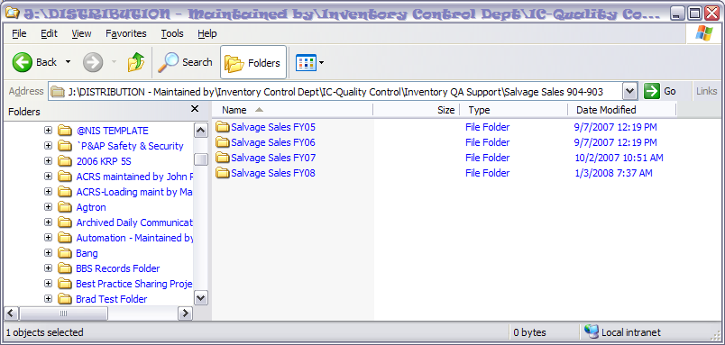
- Open the “Template.xls” spreadsheet, and then click on the “File” menu:
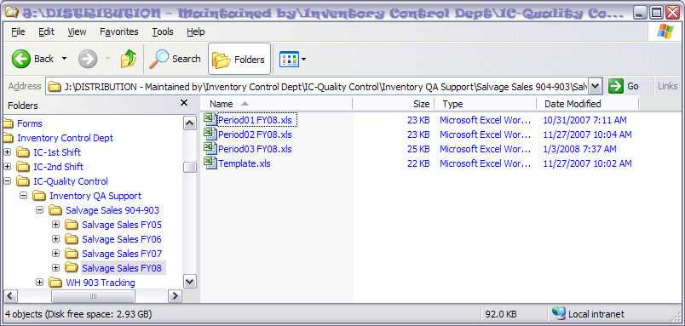
- Click on “Save As” and save the Salvage Summary with a new name. In this case it is being saved as “Period4FY08.xls”.
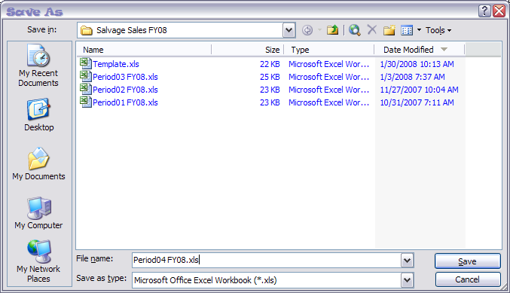
- Open up the QA Master Workbook. This Excel spreadsheet is located at: J:\DISTRIBUTION - Maintained by\Inventory Control Dept\IC-Quality Control. Copy all the NIS coffee rows in the “QA Sell” worksheet:
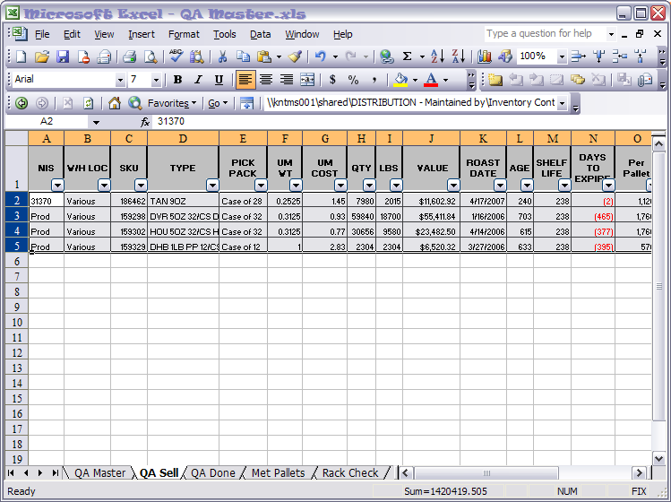
- Go back to the “Savage Summary” spreadsheet. Click on cell A2, from the “File” menu, select the “Paste Special” option, click on “Value”, and then click the “OK” button to paste the copied rows into the spreadsheet:
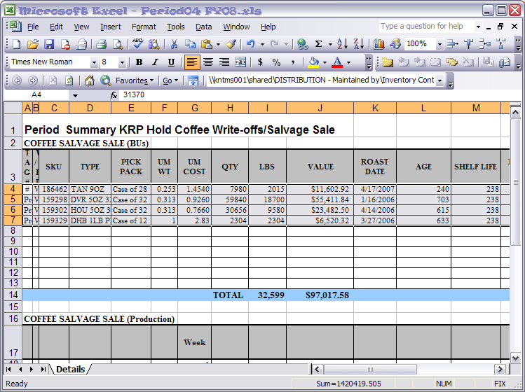
- The Production Salvage information can be obtained from Mark Coker (mcoker@starbucks.com). He sends out a report once a week, for example:
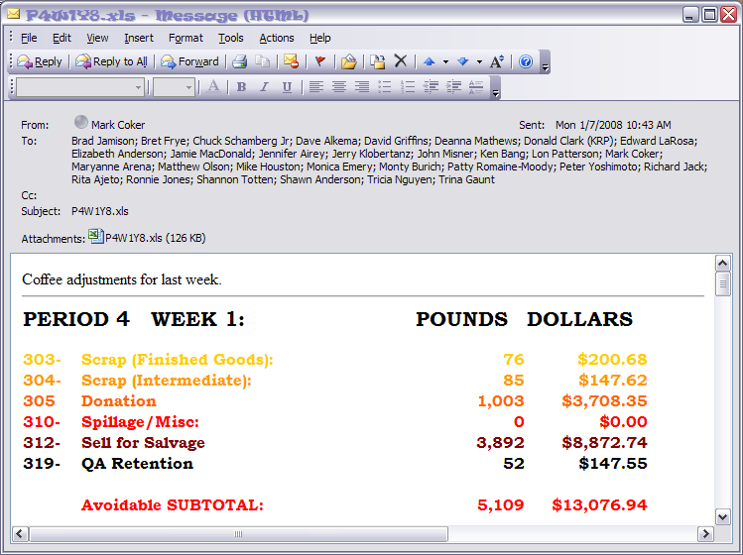
- There will be either four or five reports (one for each week of the period), depending on how many weeks are in the period you are reporting. Enter the pounds and dollar amounts for line “312-Sell for Salvage” from each weekly report to the “Coffee Salvage Sale (Production)” section of the spreadsheet:
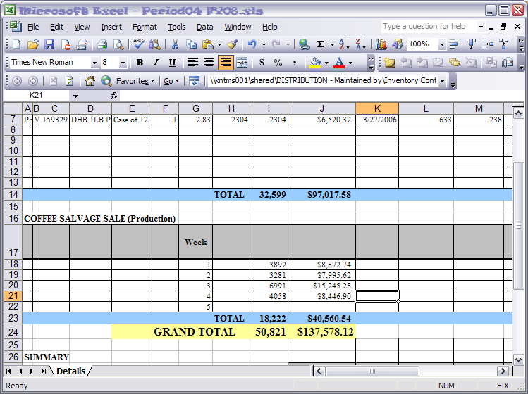
- Production’s totals will automatically show up on line 28. For the other Business Units, you will have to determine what lines belongs to what Business Unit (column T, rows 4 – 13). In this case, Retail owns lines 4 and Distribution (87) owns lines 4 - 7:
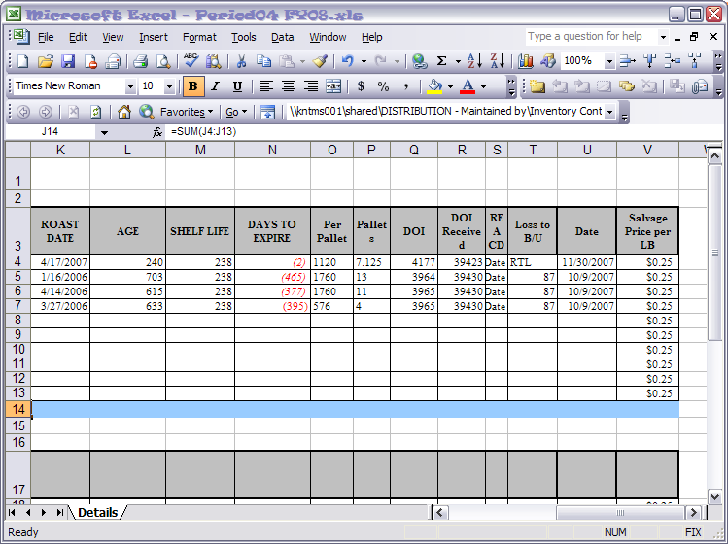
- Thus, it is charged as follows on lines 29 and 30:
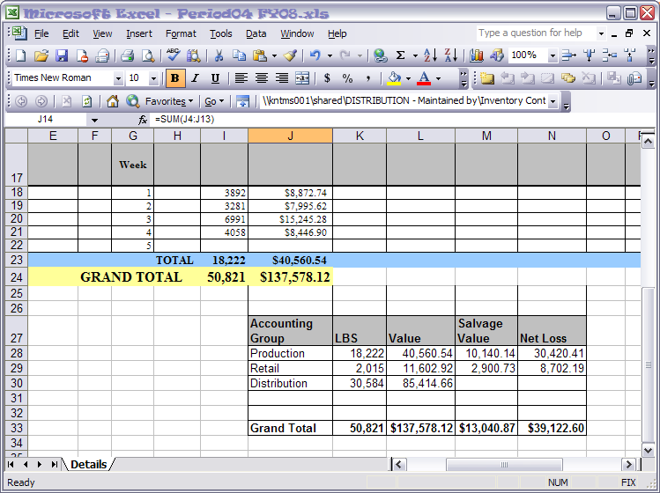

- Select cells F27 to J 33 and then press Ctrl-C to Copy:
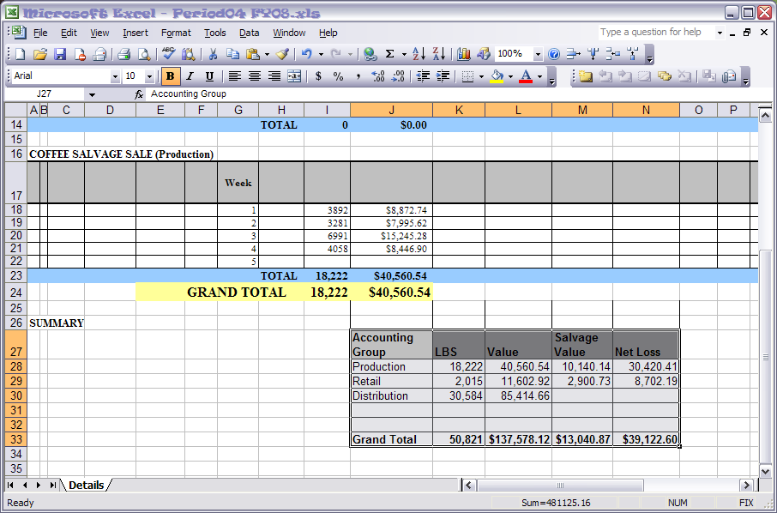
- Open a blank email and paste (Ctrl-V) the summary into the body of the email. Address to “Cassie Van Pay” (cvanpay@starbucks.com). For the subject, enter something similar to “Period 4 Summary KRP Hold Coffee Write-offs/Salvage Sale”. Attach a copy of the spreadsheet - J:\DISTRIBUTION - Maintained by\Inventory Control Dept\IC-Quality Control\Inventory QA Support\Salvage Sales 904-903\ and send the email:
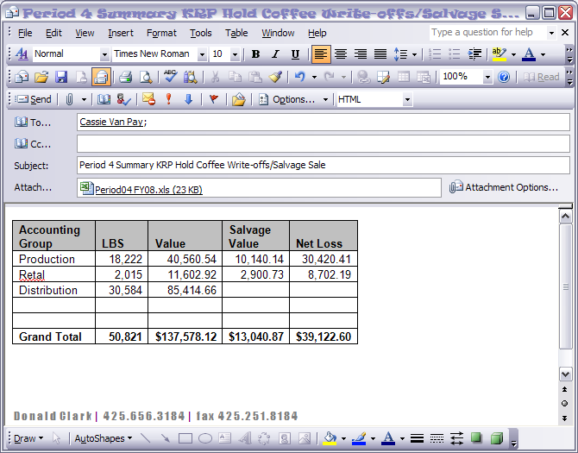

- After report is finished, move (cut and paste) the “Sell” worksheet NIS coffees to the “Done” worksheet:
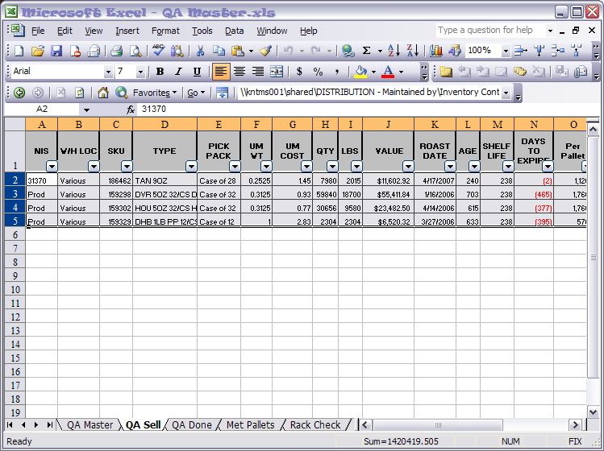
- The “Sell” worksheet is now blank to start the next reporting period:
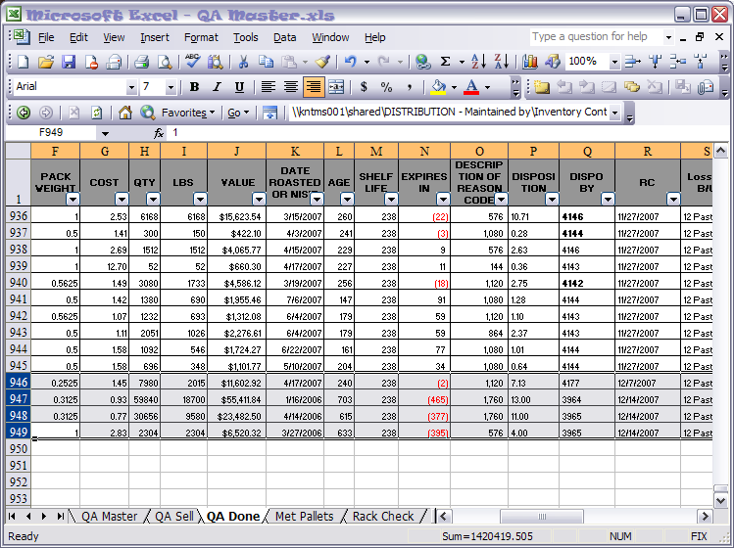

- Save and Close the workbooks.

